LE CAVITA' ARTIFICIALI DEL TRENTINO – ALTO ADIGE:
UNO SGUARDO D'INSIEME

by Marco Meneghini
Administrator of the Trentino – Alto Adige Artificial Caves Registry
of the Italian Speleological Society and the Tridentine Alpine Society

In Trentino – Alto Adige, la regione più settentrionale d'Italia, posta al confine con l'Austria, il fenomeno delle cavità artificiali ha un'eccezionale diffusione, legata a molteplici fattori storici, economici e geografici. Le opere più significative sono senz'altro quelle militari (il Trentino fu uno dei teatri principali della Prima guerra mondiale sul fronte italiano) e le miniere (scavate in particolar modo nel periodo rinascimentale). La speleologia locale, che sinora si era occupata di cavità artificiali in modo saltuario, sta affrontando studi e ricerche sull'argomento in maniera sempre più diffusa e approfondita, soprattutto grazie alla recente istituzione del Catasto regionale delle Cavità Artificiali, gestito in collaborazione dalla Società Speleologica Italiana e dalla Società Alpinisti Tridentini.

THE ARTIFICIAL CAVITIES OF TRENTINO – ALTO ADIGE: AN OVERVIEW.

In Trentino-Alto Adige, Italy’s northernmost region, situated on the border with Austria, the phenomenon of extensively scattered artificial cavities is exceptional and it is tied to various historical, economic and geographic factors. The most significant ones certainly are the military ones (Trentino was one of the main Italian battlefields during the 1st World War) and the mines (dug mainly during the Renaissance). Local speleologists, who were not very active in exploring artificial cavities up until recently, are now performing frequent and intensive studies, especially thanks to the recent creation of a regional registry designed to record artificial caves and run in cooperation with the Italian Speleological Society and the Tridentine Alpine Society.

TRENTINO – ALTO ADIGE: SHORT GEOGRAPHICAL AND HISTORICAL OVERVIEW

Trentino – Alto Adige Südtirol^{[1]} is Italy’s northernmost region, and its morphology is mainly characterized by mountains, and in particular by the presence of the central Alps. These reach the highest height at almost four thousand meters on the Ortles – Cevedale mount.
There are small portions of flat land along the valleys of the main rivers, particularly the river Adige (which flows into the Adriatic sea) and the river Isarco (which is one of its tributaries). This is where the main cities of the region are located, i.e.: Trento, Rovereto, Bolzano and Merano. Thanks to the presence of these deep valley tracks, which run along the regional territory, particularly from North to South, Trentino – Alto Adige is an important passageway: this region is situated on the border with Austria to the North (the Brennero Pass is the main link between Central Europe and Italy), with Switzerland to the West, with the region Lombardy to the South and to the West and with the region Veneto to the South and to the East.
The alpine and rural landscapes, and the rich historical and artistic monuments of the cities make Trentino – Alto Adige a beloved touristic spot.
From an administrative point of view, the region is divided into two provinces having a special autonomy: Trento (Trentino), with an Italian-speaking majority, and Bolzano (Alto Adige – Südtirol), with a German-speaking majority. There are other protected minority groups, and in particular the Ladins, living in both provinces, and the Cymbers and the Mokens (German-speaking people whose presence here is due to the migrations of the past centuries, and connected to the mining activity) in Trentino.
The territory which is now Trentino – Alto Adige was originally inhabited by various populations (Venetian - Illyrian, Retes, Gallic, etc.), and it was finally conquered by the Romans in 15 b.C. After various barbaric invasions, and after the Lombard and Frankish dominations, the Region became part of the Holy Roman Empire. Subsequently, in the 11th century, the Emperor established the Bishop’s Principalities of Bressanone (in Alto Adige) and of Trento, with the aim of strengthening his relations with the Church. The Bishop’s Principality of Trento, in particular, was destined to influencing the events of the entire area with its economic and political power, up until the arrival of Napoleon Bonaparte.
The Restoration, taking place in 1816, finally assigned Trentino – Alto Adige to Austria, which added it to Tyrol and thus fuelled the Italian irredentist forces. Adding this land to Italy became one of the main aims against Austria, and, during the Third Independence War almost seemed reached, until however the Savoy troupes entered into Trentino only a few kms away from the main city, in 1866, but then retreated.
Right after the end of the First World War, in 1918, Trentino – Alto Adige became part of the Kindom of Italy under the name of Venezia Tridentina. This, however, caused a series of requests for autonomy from the German-speaking minority. Today’s independence of these two provinces is due to a long-lasting negotiation, which at times also became particularly delicate and difficult but which, in time, diminished strongly.

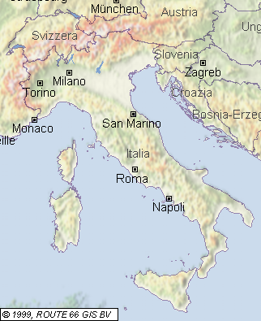

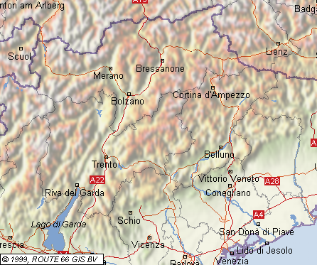

Fig. 1 General and detailed geographic overview of
Trentino – Alto Adige Südtirol (Italy)

ARTIFICIAL CAVES IN TRENTINO-ALTO ADIGE

In Trentino-Alto Adige, artificial caves are exceptionally widespread, due to a number of economic as well as geographical factors. It is possible to state that there are several thousand caves, though it is almost impossible to calculate their number with any degree of accuracy.
In addition to this, until 2004 the region did not have an organic archive collecting a relevant amount of data and classifying artificial caves in various typologies.
The creation of the Trentino – Alto Adige Artificial Caves Registry, which will be described below, may fill in the gap. The registry will only become a remarkable database in a little while, since the relevant information have only just started being collected: as a matter of fact, in July 2005 twenty-three caves were officially recorded.
Many more are still waiting to be included in the registry, since interesting classification studies, involving artificial caves located in various parts of Trentino Alto-Adige, are taking place but have not been concluded yet. It should also not be forgotten that the classification procedures are new for many speleologists: this results in a series of practical difficulties and in the lengthening of the time requirements, as it invariably happens when a system has not been fully tested and acquired.
The lack of a registry of artificial caves does not mean, however, that no documentation is present. Bibliographical references are countless; the archive documentation is also remarkable, especially the documents concerning extractive activities, which are property of the Mining Service of the Autonomous Province of Trento.
By merely analysing the documentation available, some extremely interesting caves which had fallen into oblivion for decades or even centuries can be identified. It may prove difficult, however, to find these caves, because of the loss of historical memories, or because the younger generations are less familiar with the local territory, or because some areas have gradually become depopulated. In such cases, a new discovery or the restoration of artificial caves is particularly important in the valorisation of the territory and has beneficial results on tourism.
It is clear then that the current state of the research and data collection does not provide a clear and complete description of the situation. This work aims to be a broad introduction to the phenomenon and will hopefully be followed by more detailed and accurate studies at a later stage.

HYDRAULIC WORKS

Trentino-Alto Adige is particularly rich of surface and deep water, a precious element for the economic development of the area. There is some evidence of this typology of caves: a roman well was recently found in Arco (Trento).
From a speleological point of view, however, some more interesting examples date back to the 19th century, namely some interception tunnels created to meet the requirements due to the growth of some towns in Trentino: there is the gallery of the Citàgol aqueduct (CA 2 VT TN) in Mezzolombardo, in the valley of the river Adige, and the 125-metre-long Sperone spring (CA 23 VT TN) in Riva del Garda.
An interesting section is the remarkable network of hydroelectric tunnels, spanning tens of kilometres, dug in the 1950s to produce electric power in order to cope with the increasing requirements of the industries during the economic boom following the end of the Second World War. In that case water proved to be a great source of wealth for a scarcely industrialised region, though it had a particularly traumatic social and environmental backlash: the hard working conditions of the workers, with many tragic accidents, should not be forgotten.

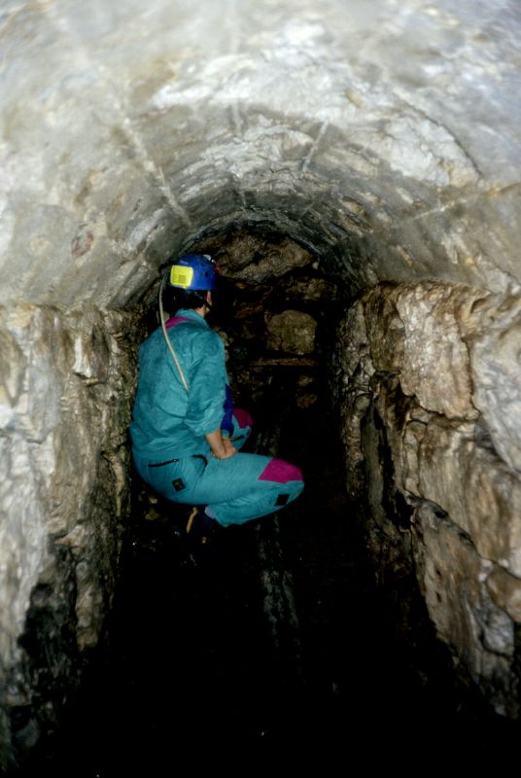

Fig. 2 Interception tunnel in the Citàgol aqueduct (Mezzolombardo – Trento).
Pictures by the author.

MINING WORKS

The presence of underground mining works has had remarkable historical, geographical and social effects in Trentino-Alto Adige; the first caves of this type, in all likelihood, date back to the early Middle Ages, there is evidence of them since the end of the 12th century. Their existence is tightly connected to the investitures of the powerful vassals of the Holy Roman Empire, particularly the Bishop Prince of Trento. The power of these feudatories was based on the mines, scattered on the mountains throughout the region, from which metals were extracted (mostly silver, but also cupper and lead), making it possible for them to coin money. The importance of the mining activity in Trentino is highlighted by the fact that the first European mining code was issued by the bishop of Trento, Federico Vanga, at the beginning of the 13th century.
Medieval mining works are countless and have formed complex structures. Some of the areas hosting the highest numbers of caves are the mountains north of Trento on the left bank of the river Adige, particularly Mount Calisio, also called Argentario. There are also many mines in Valsugana and in the Cembra Valley (eastern Trentino).
Alto Adige is rich of this type of caves, too, including the Monteneve and Ridanna structures, recently opened to tourists, in which the highest entrances are located at more than 2000 metres above the sea level.
Mining activities were carried out in the same old structures, through ups and downs, until the second half of the 20th century, although the requirements of the industrial development only focussed on some other materials, like baryta, fluorites and cadmium (in the Ridanna Valley).
Starting from the Middle Ages, mining activities resulted in a series of migrations, especially from northern Italy and central-eastern Europe, which had a deep impact on the local society and culture; these movements continued until the main mines were closed, that is until very few decades ago.

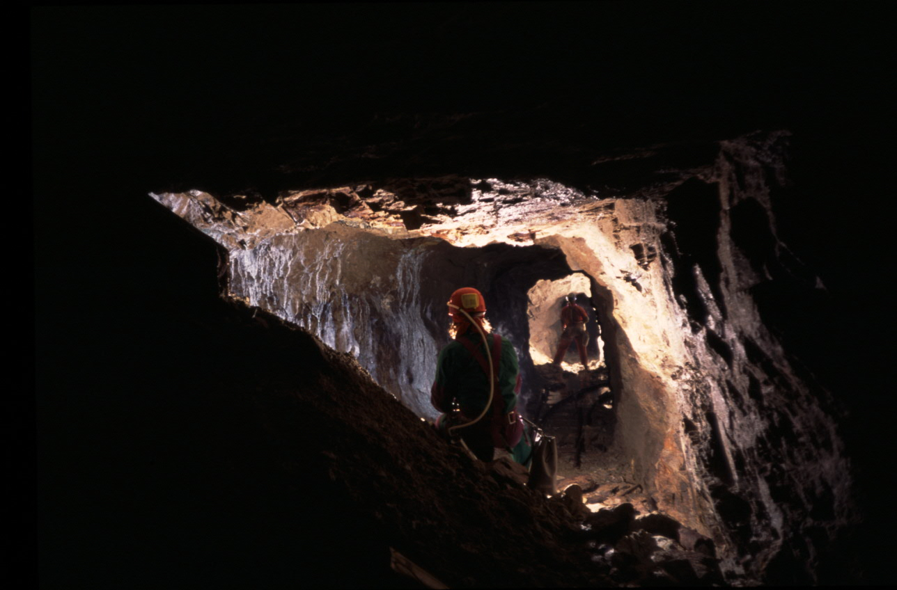

Fig. 3 Inside the mine of Vignola Falesina (Valsugana Valley – Trento).
Picture by Daniele Sighel.

MILITARY WORKS

Military works, along with mining works, resulted in the most fascinating caves in Trentino-Alto Adige. This land is the ideal link between north and south, for commerce and for invasions, which have taken place a number of times for thousands of years. The morphology of the territory, which is characterised by mountains and valleys (most of which are closed and easy to control), has favoured the building of countless castles, especially during the Middle Ages and the Renaissance. According to the legends, many of these castles have underground passages, though their existence must obviously be proved.
In any case, underground defensive works reached their heyday in the middle of the 19th century.
Alto Adige and Trentino, belonging to the Austrian Empire, started being threatened by the new Italian state when it obtained full control of the Lombard-Venetian Kingdom. Therefore, the Austrians started a large fortification programme to defend both the boundaries and the towns, especially Trento, by creating a defensive belt on the surrounding hills.
The typologies of defensive works built until 1914, however, did not include any major underground work, but were mostly defences on the ground, at first made of stone, then reinforced concrete (for example, the forts near Trento, like Mattarello and Romagnano). There are some caves, though, used as storage areas or passages, like the entrance tunnel of the Bus de Vela fort, not far from the city of Trento.
When the First World War broke out, the new military techniques resulted in a multiplication of military underground works. The mountains of Trentino and Alto Adige became the battlefields of bloody battles between the Italian and the Austro-Hungarian armies, and for this reason both enemies built artificial caves, often in places so hard to reach that we can hardly believe they could have made such enormous efforts.
To the west, in the area of mount Adamello, close to the boundary with Lombardy, the highest battle in the entire war was fought: it took place on the eternal glaciers, at more than 3,000 metres of height. Very long tunnels were dug, in order to protect soldiers from enemy attacks as well as the inclement weather.
Great fortifications for the artillery were made in the southern sector, for instance a fortified tunnel with areas for the artillery near Riva del Garda, the so-called Tagliata del Ponale (CA 3 VT TN), more than one kilometre long, and the forts of Mount Brione.
In the eastern sector, the Pasubio area, located between Veneto and Trentino, where a long underground battle took place and the most important structures are the Austrian fortified complexes of Corno Battisti and Forte Pozzacchio are located, should be mentioned. While tunnels were being built along the frontline, the defences of the town of Trento were also strengthened, by digging military caves in previously fortified places (Mount Calisio, Mount Celva, Tagliata di Civezzano).
Fortification works did not end at the end of the Great War, in 1918: in the 1930s and 1940s the Italian government implemented a defence programme along the northern boundaries, which also involved Alto Adige, in order to prevent a possible attack from the North.
Along the main valleys, a series of reinforced cement bunkers was developed, occasionally underground, with narrow passages leading to huts and shooting positions for machine guns and small pieces of artillery.

OUTLINE OF THE DEVELOPMENT OF SPELEOLOGY IN THE REGION: TRENTINO ALTO ADIGE ARTIFICIAL CAVES REGISTRY

Speleology in Trentino developed towards the end of the nineteenth century thanks to some explorers and geographers who were associated to the Tridentine Alpine Society, to which speleologists are still strongly connected today. In the province of Trento there are now seven groups, which are all part of different sections of the Tridentine Alpine Society, which is the Trento section of the Italian Alpine Club.
The situation in the province of Bolzano is the same: there are two speleological associations, and both are connected to Alto Adige Italian Alpine Club.
Many speleological groups have been active for many decades, and their activity was full of explorative and scientific results of great importance. However, up until now they have only dealt with natural cavities, at least officially.
The study of man-made cavities is creating an increasing interest for speleologists in Trentino – Alto Adige, thanks to the widespread presence of caves and to the high historical and anthropological value they hold.
Over the past few years, the situation has further evolved, and speleologists have become more involved in the survey, research and recovery of artificial caves. This, however, did not create occasions for the discussion of this topic and, most of all, this did not involve the creation of a reference database.
A Registry for natural caves was created at the end of the 1920’s, but we had to wait until the year 2004 to have something similar for artificial caves. In that year, the Tridentine Alpine Society and the Italian Speleological Society created the Trentino –Alto Adige Artificial Caves Registry. The creation of this registry had strongly been requested by both societies.
The idea of a cooperation between the Tridentine Alpine Society and the Italian Speleological Society was developed keeping into consideration the experience acquired and the good working methods which the Italian Speleological Society had already used for artificial caves (the Italian Speleological Society national registry dates back to 1981). They also kept into consideration the strong presence of the Tridentine Alpine Society on the territory, as it is an historical society, established in 1872, which has a great prestige locally and which gathers all speleological groups of the province of Trento.
This cooperation includes the Alto Adige section of the Italian Alpine Club for the province of Bolzano, thus allowing territorial continuity of the Artificial Caves Registry in the entire region.
The regional Artificial Caves Registry is part of the National Artificial Caves Registry of the Italian Speleological Society, and it uses the same data acquisition and conservation procedures, in cooperation with the Tridentine Alpine Society for its management and, most of all, with the Registry Work Group (which had already been established to coordinate and catalogue natural cavities) in which take part all the representatives of the speleological groups of the region. The aim of this register is to catalogue all anthropical caves, by collecting the data which determine their extension, their position and which allow their identification according to the models and the procedures defined by the Italian Speleological Society. The person in charge of the Artificial Caves Registry is a member of the National Artificial Caves Commission of the Italian Speleological Society: this allows a local operational autonomy of the Registry and it also allows a direct participation of Trentino – Alto Adige speleologists in projects of wider scale, both national and international.
The job done to start the Registry was excellent, especially considering the speed with which the results were reached and the tools which can now be used. Everyone cooperated at best with each other and with myself, in my role as the administrator and as the person in charge of the Registry.
The Trentino – Alto Adige Artificial Caves Registry is awaiting for the official recognition by local bodies, since it is a precious database for the safeguard of the territory. We hope that this will take place shortly, with the help of the ones who are more involved, such as the region Trentino – Alto Adige Sudtirol and the Autonomous Provinces of Trento and Bolzano.
At first a lot of time and energy were spent for the creation of the Registry, for the contacts, the technical meetings, the definition and the approval of the rules.
Subsequently, the Registry was advertised on the press and to the people having an interest in it. This included a training and didactic activity to those who can give or use the data in the future. We must bear in mind that for most speleologists from Trentino, artificial caves are a whole new topic: a lot of the people involved are not familiar with the working procedures, with the classification of caves of various kinds, with the technical and historical aspects of cavities. This is the reason why we organized training classes, aiming not only to speleologists.
In fact, in Trentino – Alto Adige artificial caves are of great interest also for amateurs and scholars of other sectors: historians, people interested in the places where the Great War took place, in minerals, and so on, who regularly attend and study military and mining works, and publish works and studies of great interest. Therefore, the Registry must not remain within the speleological field, as it was created to interact with a varied and complex reality, allowing to handle data at best and to coordinate researches and activities at best.
The caves which have been registered until now are scattered in the province of Trento, and can be classified into the following typologies:
- A – Hydraulic works: 2
- D – Military works: 16
- E – Mining works: 4
- Promiscuous works: 1 (typol. A – D)
Caves were numbered according to the directions of the Italian Speleological Society: each artificial cave is marked by CA followed by a regional progressive number and by the letters indicating the region and the province where the cave is located, and then followed by a progressive number. The letters used by the Artificial Caves Registry of Trentino are VT/TN, and VT/BZ indicates the artificial caves of Alto Adige.
Please note that the regional acronym for Trentino – Alto Adige is VT, which is Venezia Tridentina, deriving from the first official name of the region, dating back to the 1920’s, right after the First World War, when Trentino – Alto Adige was annexed to Italy: Venezia Tridentina precisely coincided with the regional territory of today.
We chose VT for artificial caves mostly for historical reasons, and to conform artificial caves data to the data in the Trentino – Alto Adige Natural Cave Registry, which was created when the official name of Trentino – Alto Adige was Venezia Tridentina. The acronym used at the time, VT, is still used today in the Natural Caves Registry.

THANKS

I would like to thank the President of the Speleological Commission of the Tridentine Alpine Society, Marco Ischia; the Administrator of the Trentino – Alto Adige Cave Registry, Riccardo Decarli; the Artificial Caves Commission of the Italian Speleological Society; Arianna Tamburini; Giuseppe Fantauzzi; Enrico Fratnik; Daniele Sighel and the Trentino Speleological Group from Villazzano – Trento for helping me with this report.

BIBLIOGRAPHY
ARDITO F., 2002. Le miniere di Monteneve e Ridanna. Opera Ipogea – Memorie della Commissione Nazionale Cavità Artificiali, Genova, 4 (3): 52 – 56.
BORSATO T., MARZI C.,1998. Trento città fortezza. Trento.
GORFER G., 2004. La storia, da: Il Monte Celva. L'ambiente e la storia. Trento, 57 – 112.
ISCHIA M., TAMBURINI A., 2004. Percorsi di guerra. Speleologia – Rivista della Società Speleologica Italiana, Bologna, 25 (2): 28 – 39.
MARTINELLI V., 1989. Un generale bresciano nella Grande Guerra (Achille Papa – Medaglia d'Oro). Montichiari (BS).
MENEGHINI M., 2005. Nasce il Catasto delle Cavità Artificiali del Trentino – Alto Adige". Mondo sotterraneo – Notiziario di speleologia del Trentino – Alto Adige, Bollettino SAT, Trento, 58 (1): VIII – XII.
SIMONI D., 2004. La miniera di Faedo. La nostra geografia – Giornale ufficiale della Associazione Italiana Insegnanti di Geografia Sezione Trentino – Alto Adige, Trento, 4 (1): 36 – 39.
TOURING CLUB ITALIANO, 1995. Guide d'Italia. Trentino – Alto Adige e Friuli – Venezia Giulia. Milano.
ZAMMATTEO P., 2005. Costruttori di miniere. Poster Trentino – Bimestrale della Provincia Autonoma di Trento, Trento, 5 (2): 56 – 66.

Author’s address:
Marco Meneghini
Administrator of the
Trentino – Alto Adige Artificial Caves Registry
of the Italian Speleological Society and Tridentine Alpine Society
c/o S.A.T. – Sede centrale
Via Manci, 57
38100 Trento

Home address:
C.so IV Novembre, 130
38016 Mezzocorona (TN) - Italia
Tel. 0461604063 – marcom73@libero.it

[1] The official name of this region is the bilingual one in Italian and German, Trentino - Alto Adige Südtirol.
The Trentino – Alto Adige Artificial Caves Registry has its own regulations, approved by the Central Council of the Tridentine Alpine Society on 18.10.2004 and subsequently endorsed by the Artificial Caves National Commission of the Italian Speleological Society on 30.11.2004 and by the directive council of the Italian Speleological Society on 18.12.2004.
The typology classification is the same used by the National Registry of Artificial Caves of the Italian Speleological Society. The typologies can be divided into groups and sub-groups. The groups are indicated by a capital letter, and they are: A – hydraulic works; B – inhabited areas; C- cult works; D – military works; E – mining works; F – transit areas; G – other.
For example: CA 1 VT TN – Cave located North of Romagnano (Trento)

